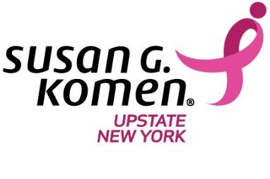

**KOMEN SURVIVOR LUNCHEON**

**AD REQUEST FORM**

Susan G. Komen® Upstate New York will honor hundreds of local breast cancer Survivors at our 17th Annual WNY Survivor Luncheon, at 11a.m. on Saturday, Oct. 6, 2018, in the Buffalo Niagara Convention Center.

About 600 Survivors and co-Survivors are expected, and all breast cancer Survivors attend the luncheon without charge, thanks to donations from generous members of the Western New York community.

Please consider placing an ad in the Survivor Luncheon program. Proceeds help support breast cancer and breast health programs in Western New York that focus on education, screening and treatment assistance for under-served individuals, as well as cutting-edge research to find the cures for breast cancer!

Company Name: ___________________________________________________________

Address: __________________________________________________________________

Contact Name: _______________________________TELEPHONE: __________________

Email Address: _____________________________________________________________

**I’d like to purchase the following (See attached examples):**

___ ¼ Page ($100) ___ ½ Page ($175) ___ Full Page ($225)

Payment Options: ☐ Please Invoice Me ☐Check by Mail ☐ I’ll call with credit card info

(716-887-2645)

**Camera-ready ads due to mmagaris@komenupstateny.org by 9/21/18 *** All ads are full color**

**Mail form with info, and/or check to:**

Susan G. Komen Upstate NY

742 Delaware Ave.

Buffalo, NY 14209

